ASSIGNMENT 1
Task 1
To take backup of the instance and launch new instance with the backup:
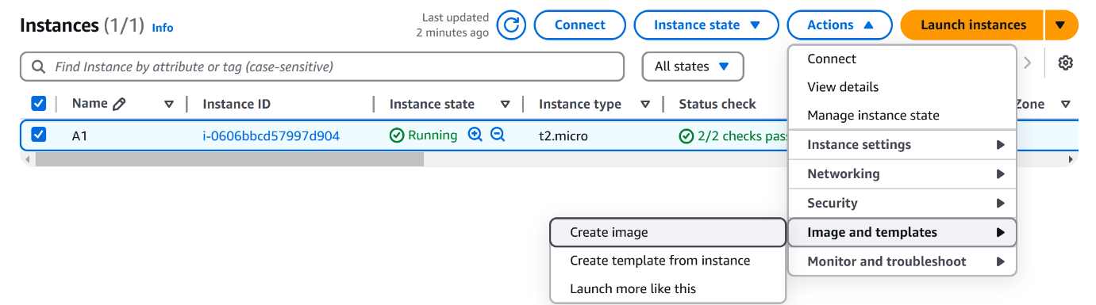
- Select the instance that you want to take a backup of ActionsImages and templatesCreate image
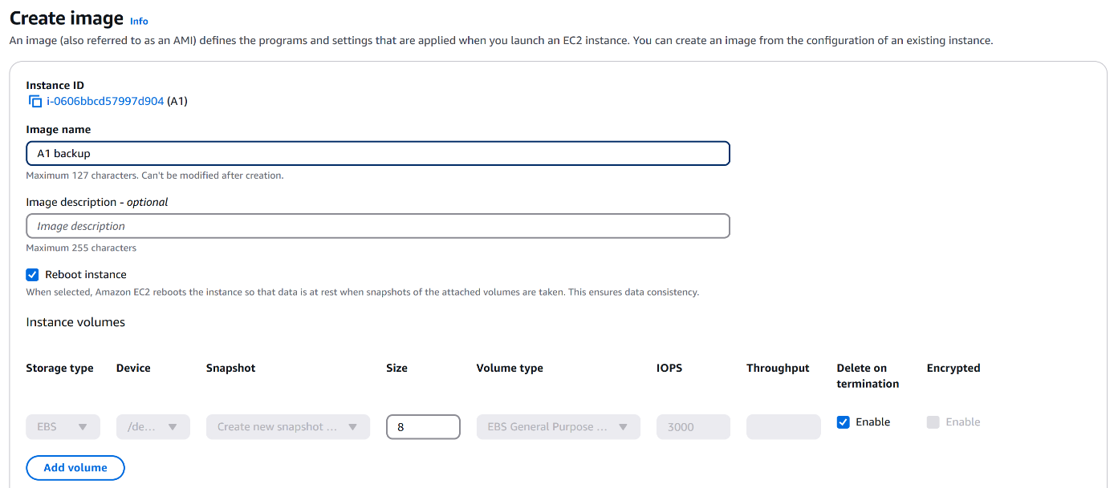
- Enter the image (AMI) nameDescription(optional)Create image
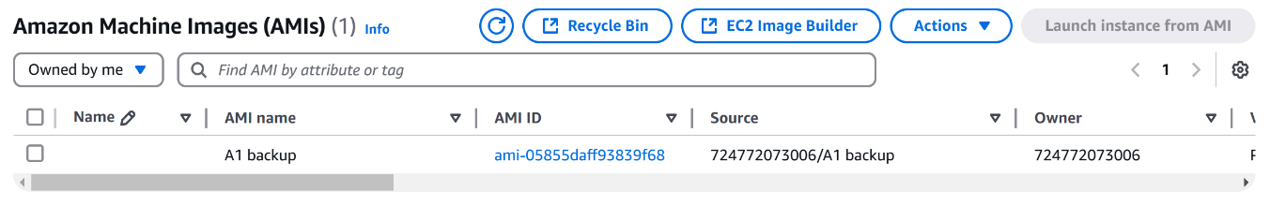
- Navigate to ImagesAMI’sYou can find that the backup has been created.
To launch a instance from the backup that has been created:
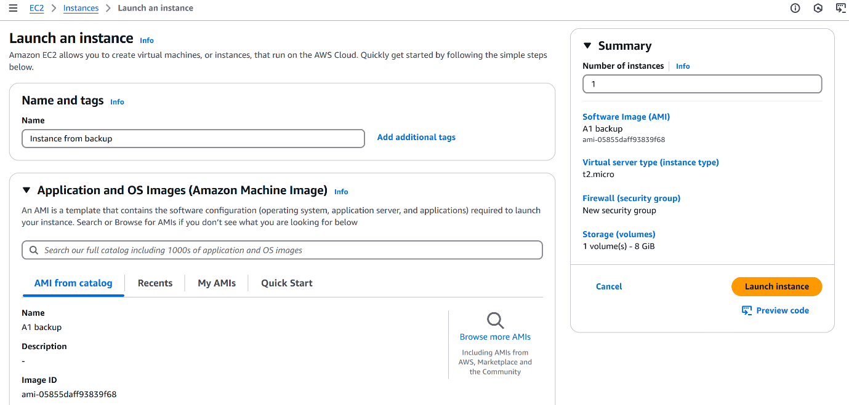
- Select the image(AMI) that you want to take a backup ofLaunch instance from AMIEnter the nameSelect instance typeKey pairNetwork settingsLaunch instance.
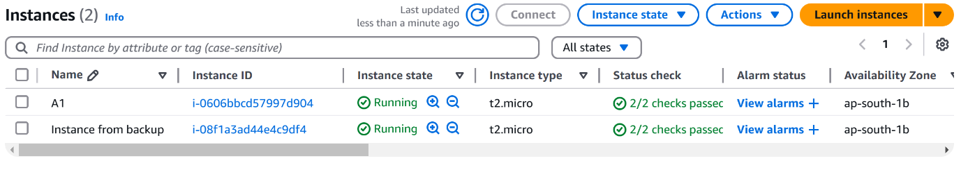
- Created a new instance from the backup:

Task 2
EBS(Elastic Block Storage):
- Under the Elastic Block Storage navigate to the volumesCreate VolumeVolume typeSizeAvailability zoneCreate volume.
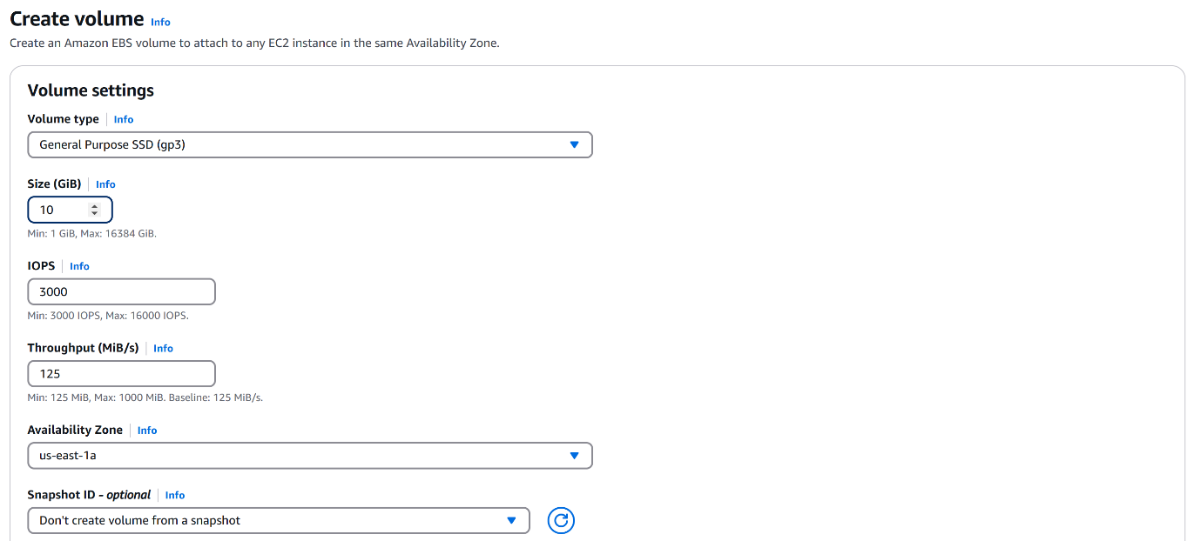
- Ensure you select the same availability zone if you want to attach it directly.
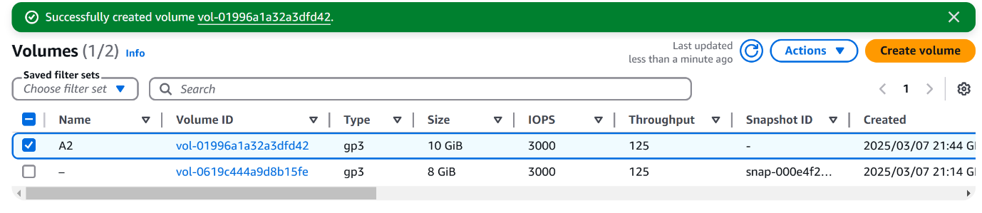
- The EBS Volume has been created.
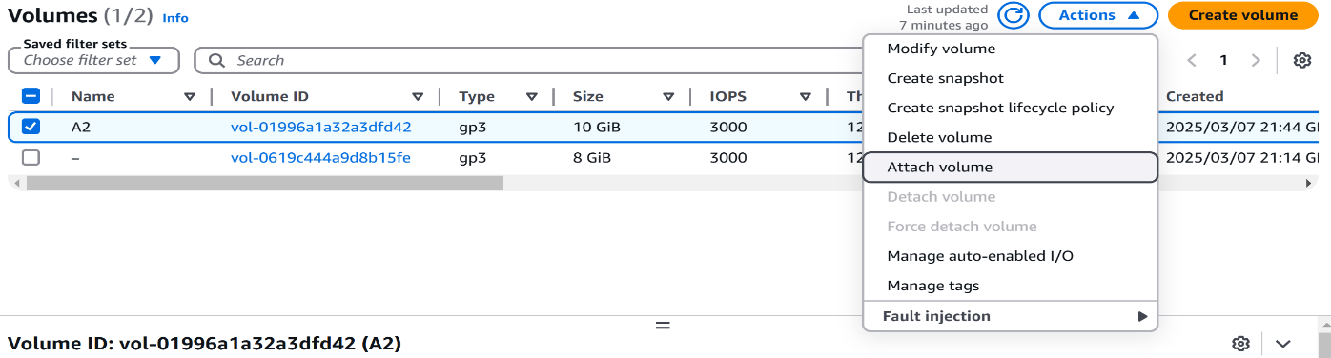
- To attach the volume go to actions tabAttach volumeSelect the instance and device nameAttach volume.
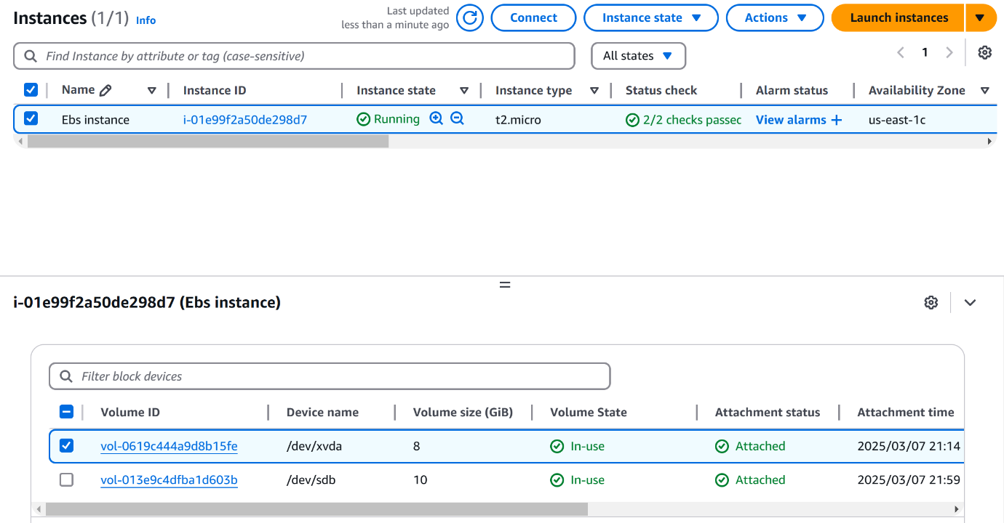
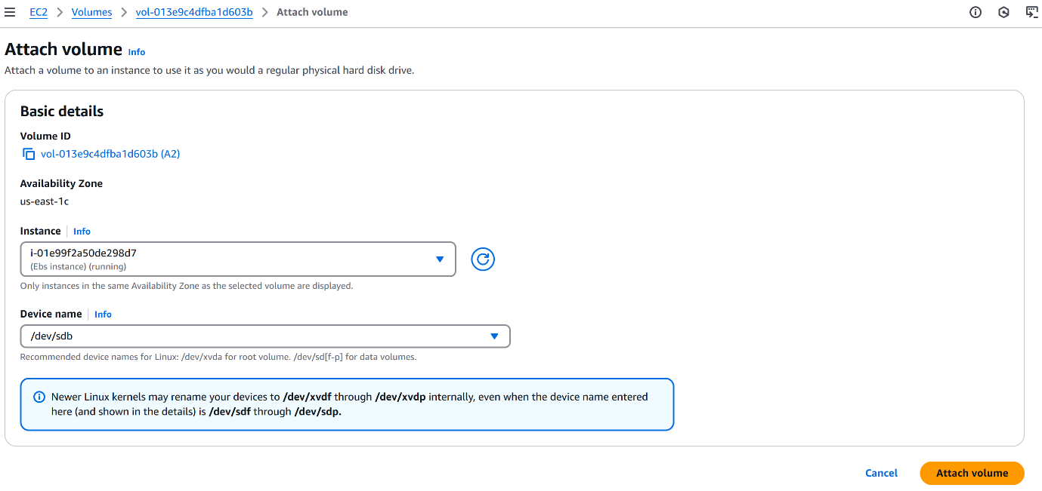
- You can check if the volume has been or attached or not by navigating to the instancesStorage.
- The EBS volume has been attached to the instance.
……………………………………………………………………………..
- To mount the volume and access the EBS connect to a linux server by direct connection or through any third party connections like Putty, MobaXterm, etc.
- Login as ec2-usersudo su(super user)lsblk command(To list the block devices),where we can find that volume has not been mounted.
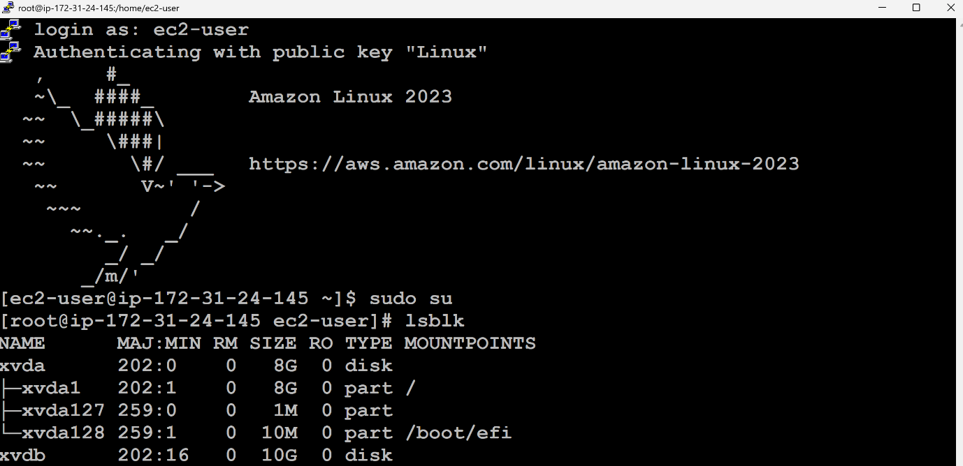
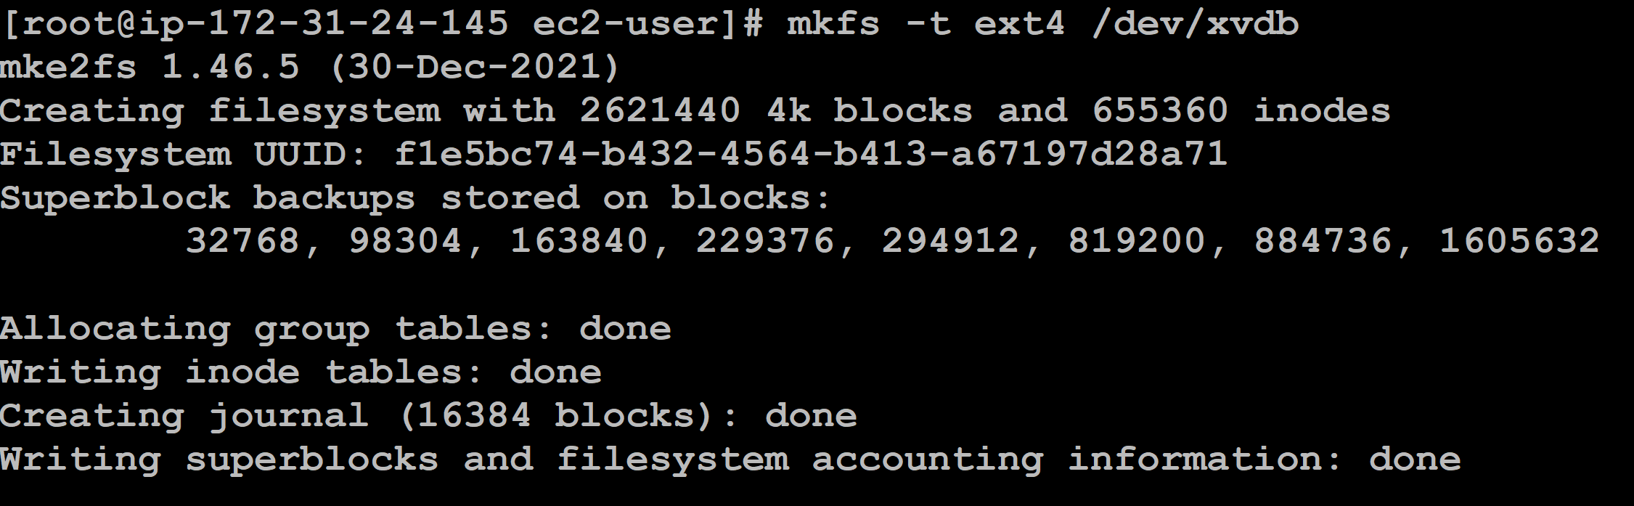
- mkfs -t ext4 /dev/xvdb(To create a file system and format the same).

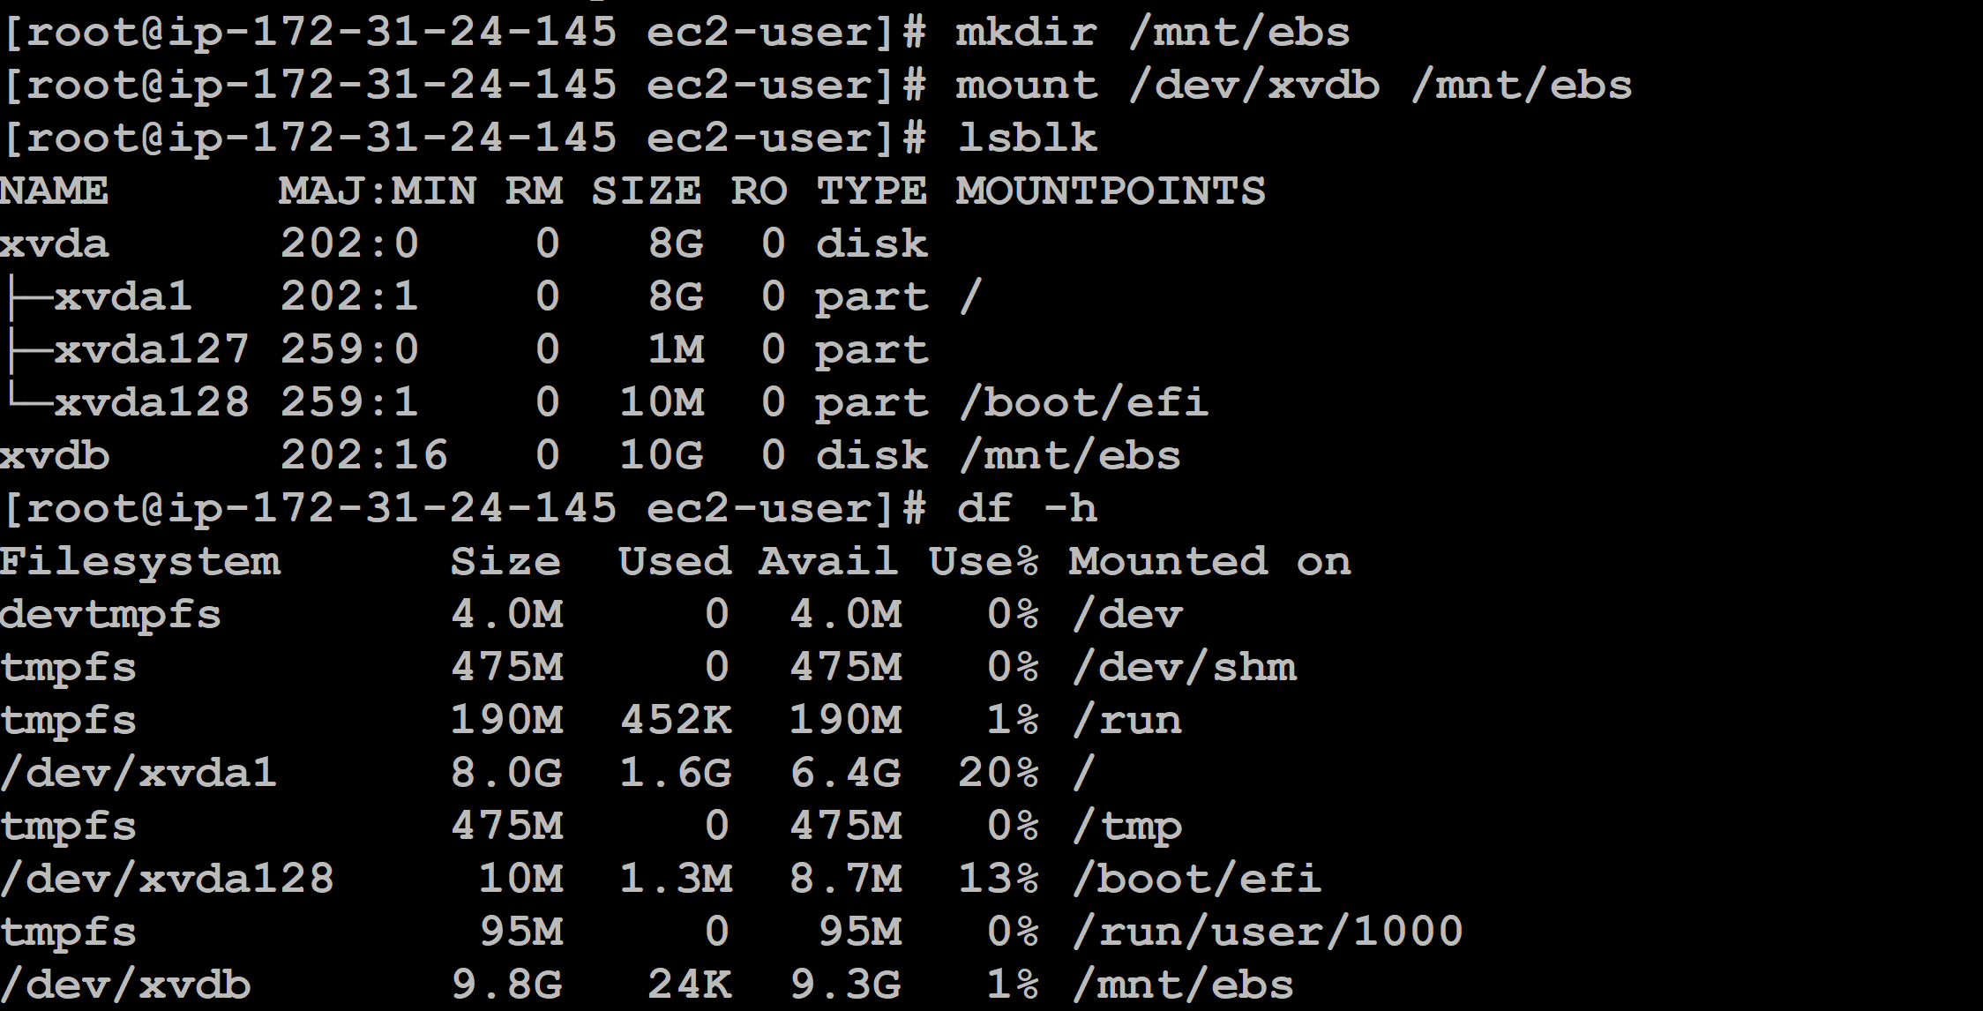
- mkdir /mnt/ebs(Creating a mount point(directory)mount /dev/xvdf /mnt/ebs(To mount the EBS volume).


- mkdir /mnt/ebs(Creating a mount point(directory)mount /dev/xvdf /mnt/ebs(To mount the EBS volume).

- By running the df -h command we could find that the filesystem has been mounted to the ebs volume.

- To access through different region we can create a snapshot of the volume from the current region(N.Virginia).
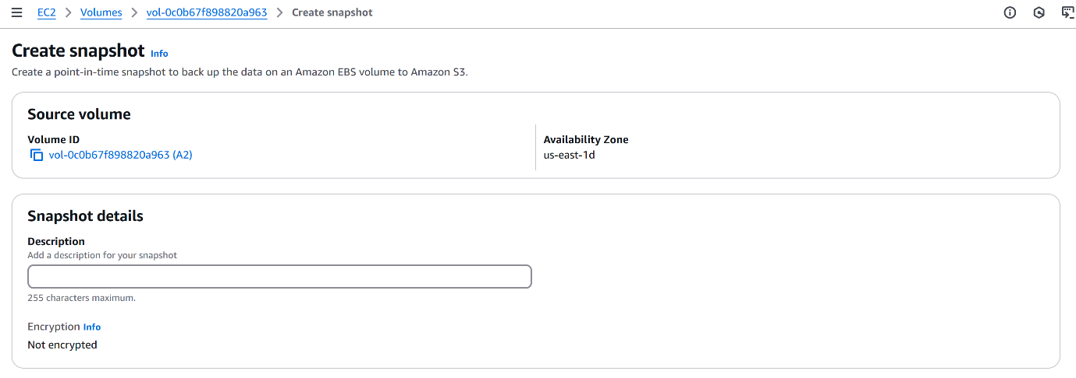
- EC2Volumesselect the volumeActionsCreate Snapshot.
- The snapshot will be created.
- To access it through different region: Select the snapshotActionsCopy snapshot.
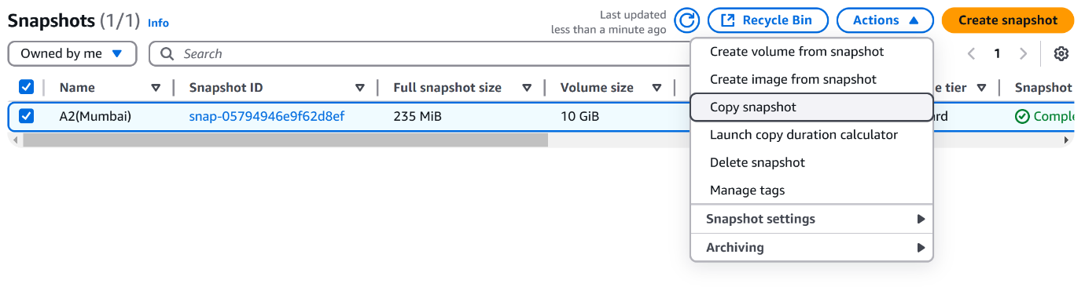
- Destination region(Select the region where you want to create a copy of the snapshotCreate snapshot,
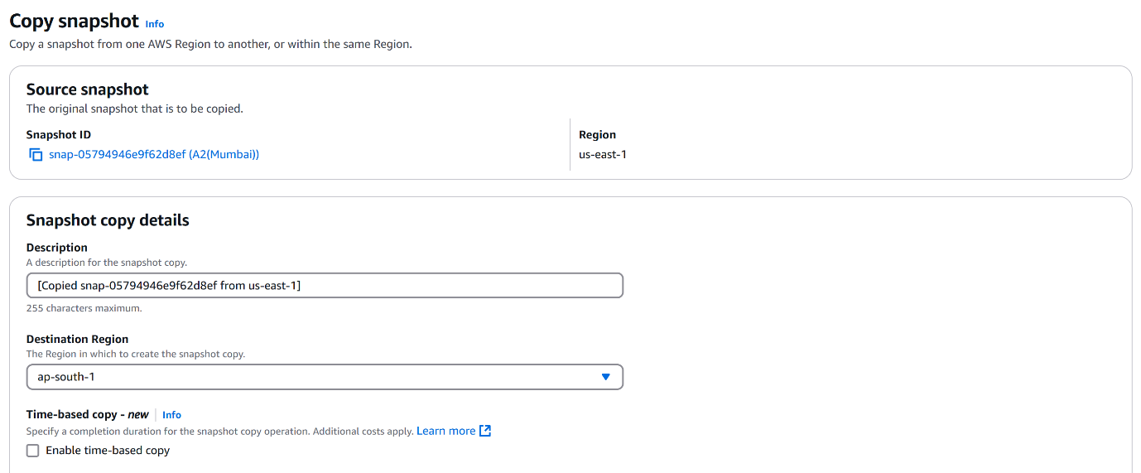
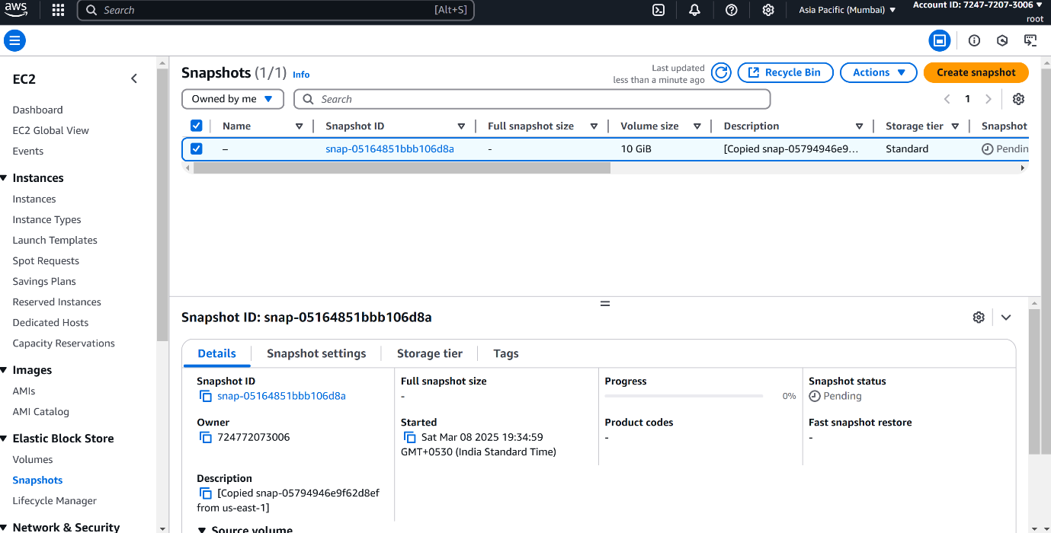
- We can find that the snapshot has been created in the destination region(Mumbai).
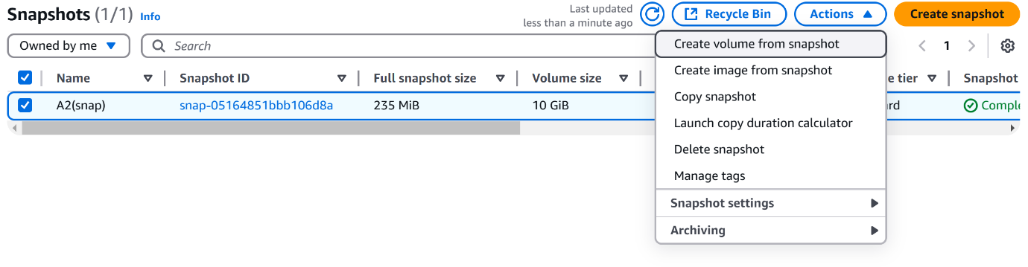
- To create a EBS volume from the snapshot: SnapshotsActionsCreate volume from snapshot.
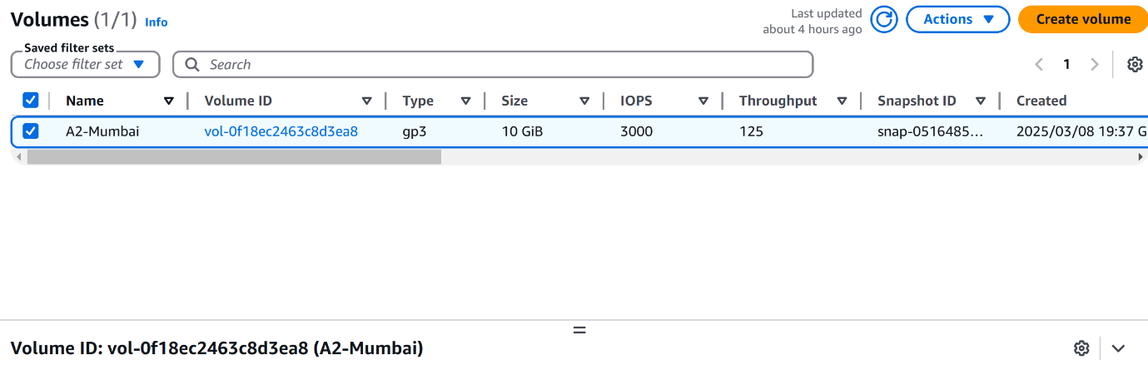
- We can find that the EBS volume has been created.
- To connect the EBS volume to the instance and attach it we can follow the previous steps and the same steps would apply for mounting and formatting in the Linux servers.
- If you want to connect with the same instance from the previous region(N>Virginia) you can use services like VPN-Virtual Private Network.

